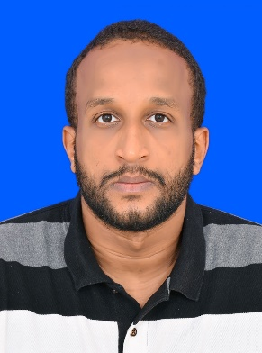
Full Stack Web Developer
Skills and technologies:
HTML – CSS – Tailwind CSS – JavaScript - TypeScript - jQuery– React – Next Js – Shadcn – Node Js – Express – ReactQuery – MongoDB – Git – Github – Uploadthing – Firebase – Mailtrap - Web3Forms

Amro Al-Mutasim
Portfolio: https://amro97-portfolio.vercel.app/
Whatsapp: +249-995291772
https://www.linkedin.com/in/amro97/
+968 79335801
amroalmutasim22@gmail.com

Work Experience

Founding developer at a startup – FEB 2024 – Present
amro97 Academy, Muscat, Alseeb

I made this academy to help people learn and apply from coding youtube projects and give them the full roadmap and guidance to become developers.

Real Projects Experience

amro97 Academy – FEB 2025
I made this academy to help people learn and apply from coding youtube projects and give them the full roadmap and guidance to become developers.

Features :
Projects lists and youtube videos - Dark mode - Multi-language by next-intl - Full Authentication

Visit the website

Todo App – JAN 2025

I made this app for real use by myself to store different things that I want to do while I'm developing, firstly I followed a tutorial and after that i added others features like the sidebar and others and I think how to code them by myself

Features :
Sidebar to select tasklists - Dark mode - Fullstack - Full Authentication

Visit the website

My Portfolio – SEP 2024
I made it as you see as a fullstack portfolio which lets me add new projects through a form, edit and delete it, I made multi-language using next-intl library, I made the dark mode and authentication to let my self sign-in and be the only one who can add projects

Features :
Fullstack - Dark mode - Multi-language by next-intl

Visit the website

Web Dev Service – JAN 2025
I made this freelance website to let people request me building websites for them as a freelancer.

Features :
Dark mode - Multi-language by next-intl

Visit the website

Education

Free Code Camp Website :
Responsive Web Design Certification – MAR 2024

British Council :
IELTS certificate – NOV 2022

ETS :
General Record Exam – GRE – MAY 2023

Ministry Of Education – Sudan :
High School Certification – April 2014

Personal Snippets

Date of Birth: 22nd March 1997
Nationality: Sudanese
Marital Status: Single
Freelance: Available
Languages Known: Arabic: native language
English: has an IELTS Certificate with overall score 6.0

Others: Has an acceptable score In General Record Exam (GRE)
Verbal Reasoning: 141 – Quantitative Reasoning: 152 – Analytical Writing: 2.5

